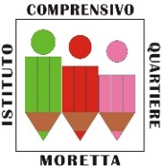

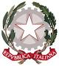
ISTITUTO COMPRENSIVO ALBA QUARTIERE MORETTA
Via Carlo Cencio n. 14 - 12051 ALBA (CN) - Tel. 0173 440360 - Fax 0173 293286
Codice Fiscale: 90051360049 - Codice Meccanografico: cnic855003
Sito web: icquartieremoretta.edu.it - E-mail: CNIC855003@istruzione.it
posta certificata: cnic855003@pec.istruzione.it

ALLEGATO 2

OFFERTA ECONOMICA E PROPOSTA PROGETTUALE

PRESENTA LA SEGUENTE PROPOSTA PROGETTUALE:
_______________________________________________________________________________________________________________________________________________________________________________________________________________________________________________________________________________________________________________________________________________________________________________________________________________________________________________________________________________________________________________________________________________________________________________________________________________________________________________________________ .

Data_______________________ Firma____________________________

